The Bolontiku Catalogue
Scales 3 to 9: glyphs, distances and time
Joshua Harmon and Claude · a companion note to the Tzolkin clock · October 2026

1. An account of the Bolontiku
The Bolontiku (Maya Bolon ti K’u, “nine gods”) are the nine glyphs known to epigraphers as Glyphs G1 to G9 of the Supplementary Series. In Classic Maya inscriptions one of them follows the date and names which of the nine is “in office” that night, so they form a running nine-day cycle. Because 360 is 40 × 9, every tun, katun and baktun ending falls on G9, and the Long Count’s zero date, 4 Ahau 8 Cumku, is a G9 day. The colonial Books of Chilam Balam pair the Bolon ti K’u, gods below, with the Oxlahun ti K’u, the thirteen gods above.
Sven Gronemeyer (2006) showed that the nine glyphs follow the life of the maize plant, the corn-stalk analogy that runs through this catalogue:
- G1 to G3, origin and preparation: “nine times conjuring”; “it arrives at the soot-place” (the burned field); “the maize flower arrives”.
- G4 to G6, the hidden passage: the young ear goes into the underworld with the night sun, is wrapped and kept, and is accepted as a ripe plant.
- G7 to G9, ripeness and end: “the first maize ear” (spelled like the word for north); “heart”, the ripe ear kept as seed; and the Sun, completion.
Names u1 to u9. As a working decision, the nine glyphs are called u1 to u9 — u for “underworld”, a letter little used elsewhere. The Moon is u1 and the Galaxy u7.
In this catalogue the nine glyphs are used as rubber stamps that sort data into nine classes by scale. Each class has a size in space, a length in time, and a glyph whose maize stage describes the kind of thing found there. This document covers the third glyph and above; the first two, the Moon and Venus, are treated elsewhere and in the clock itself.

How the scales are built
- Space: the fourth scale is the distance from Earth to Sirius, 8.60 light years (Hipparcos 2007). Each higher scale is 20 times the one before. The third scale is described by its subject, the outer planets, rather than by the yardstick divided by 20, since the lower scales do not share the same spatial properties.
- Time: each scale lasts 13 of a Long Count unit, also 20 times the one before, all ending on 13.0.0.0.0, 21 December 2012. The fourth is the 5,125-year Long Count era itself, starting 4 Ahau 8 Cumku, 3114 BC, near the first pharaohs and remembered in Maya myth as the creation of the maize people.
- The third scale: lasts 13 katuns (93,600 days, 256.3 years) and starts on the day of the first issue of the London Chronicle, 1 January 1757, so it ends on 9 April 2013. Counted back from 13.0.0.0.0 instead, 13 katuns would start on 14 September 1756, about three and a half months earlier.
- Seven divisions: every time scale divides evenly into seven parts. The catalogue lists what happened at or near each of the eight marks.
Because space and time both grow by 20 at each step, the ratio between them stays fixed at about 596 years for every light year: the 5,125 years of the fourth scale go with 8.6 light years, the 16.4 billion years of the ninth with 27.5 million light years.
Glyph | Glyph caption | Distance | What lies there | Time span
u3 | First flower at Jupiter clock U3 | about 5–50 AU | The outer planets | 256 years
u4 | AHAU | 8.6 light years | Sirius Supercluster | 5,125 years
u5 | The celestial creation arrives | 172 light years | The Ursa Major stream | 102,507 years
u6 | Perpetual regeneration-motion — First flower: Alcyone’s spiral | 3,440 light years | The Orion Arm (about 3,500 ly wide) | 2.05 million years
u7 | The first ear rises in the north: the Galaxy turns as one (proposed) | 68,800 light years | The Galaxy (Milky Way) | 41.00 million years
u8 | Maize heart holds to the dream, the galaxies Andromeda & ours | 1.38 million light years | Toward Andromeda (the Local Group’s balance point) | 820.06 million years
u9 | All is complete with one day, and in our relativistic Sun (first scale) is found the Pentadodecahedron Universe (last scale) | 27.52 million light years | The Local Group and the Local Volume around it | 16.4 billion years

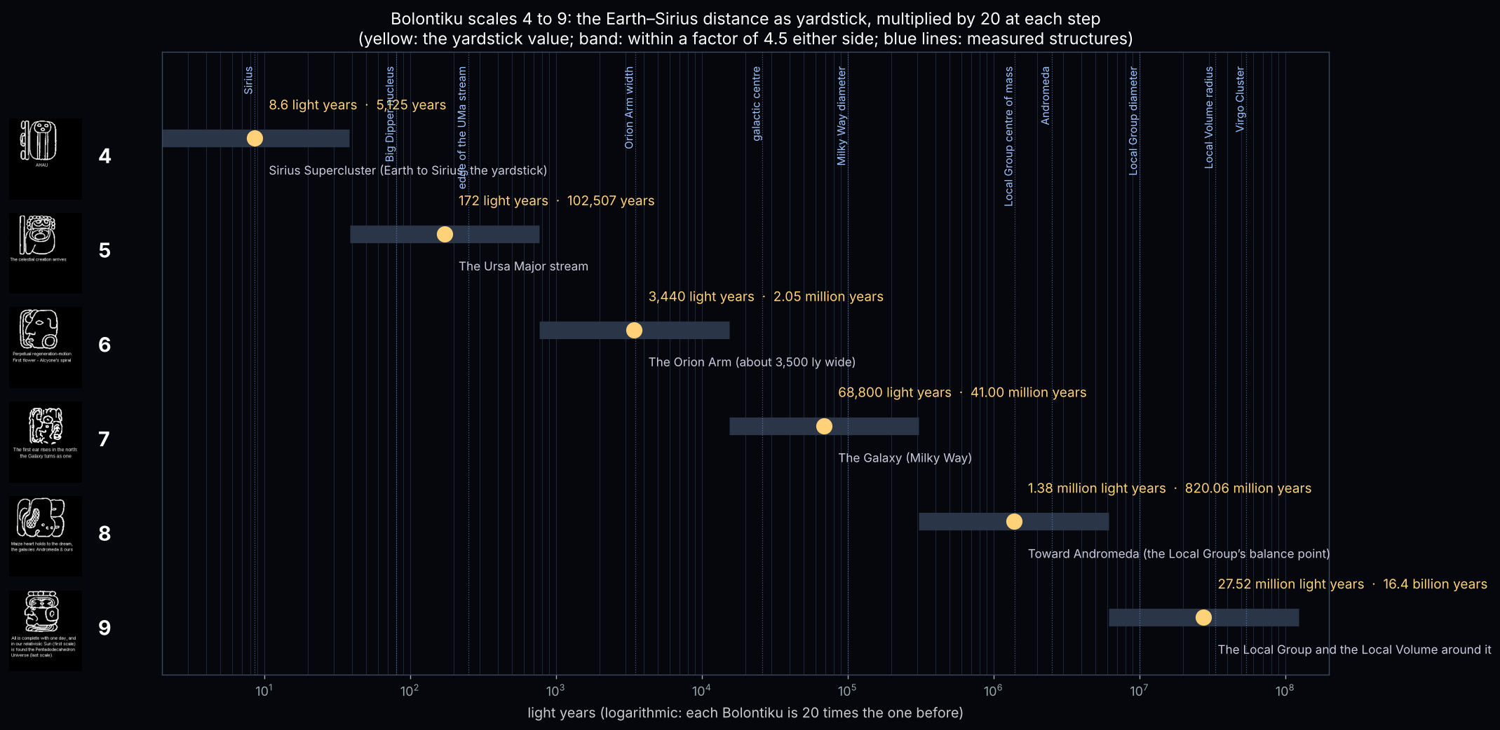
Figure 1. Scales 4 to 9 on one logarithmic ladder, with measured structures marked.

2. Third Bolontiku (u3): The outer planets
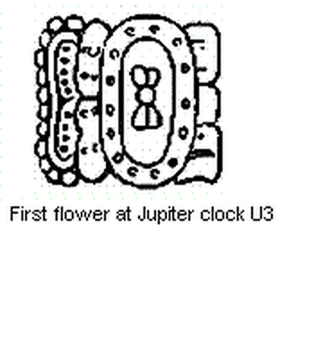 | “First flower at Jupiter clock U3”  Maize stage: HUL-JANAAB, “the maize flower arrives”: the first flowering of the young plant after the seed has gone into the burned field.  Distance: about 5–50 AU — The outer planets.  Time: 256 years (13 × katun), in seven parts of 36.6 years.

What lies at this scale. Jupiter and Saturn, with 13 great conjunctions inside this scale (1762 to 2000); Uranus circles three times (252 years) and Pluto about once (248 years).
Jupiter and Saturn meet every 19.86 years, almost exactly one katun (19.71 years), which makes this the outer-planet clock where the “end of world” numbers can be read. The scale opens with the first London Chronicle and closes as Voyager 1, sent past Jupiter and Saturn, reaches interstellar space.

The seven divisions
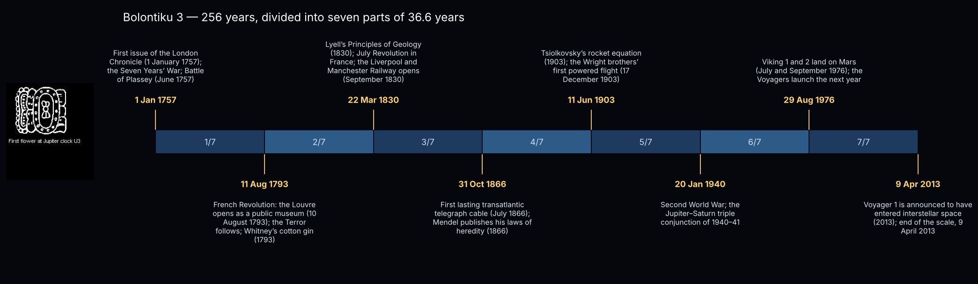
Figure 2. The third scale in seven equal parts.
Mark | Date | At or near this time
Start | 1 Jan 1757 | First issue of the London Chronicle (1 January 1757); the Seven Years’ War; Battle of Plassey (June 1757)
1/7 | 11 Aug 1793 | French Revolution: the Louvre opens as a public museum (10 August 1793); the Terror follows; Whitney’s cotton gin (1793)
2/7 | 22 Mar 1830 | Lyell’s Principles of Geology (1830); July Revolution in France; the Liverpool and Manchester Railway opens (September 1830)
3/7 | 31 Oct 1866 | First lasting transatlantic telegraph cable (July 1866); Mendel publishes his laws of heredity (1866)
4/7 | 11 Jun 1903 | Tsiolkovsky’s rocket equation (1903); the Wright brothers’ first powered flight (17 December 1903)
5/7 | 20 Jan 1940 | Second World War; the Jupiter–Saturn triple conjunction of 1940–41
6/7 | 29 Aug 1976 | Viking 1 and 2 land on Mars (July and September 1976); the Voyagers launch the next year
End | 9 Apr 2013 | Voyager 1 is announced to have entered interstellar space (2013); end of the scale, 9 April 2013

3. Fourth Bolontiku (u4): Sirius Supercluster
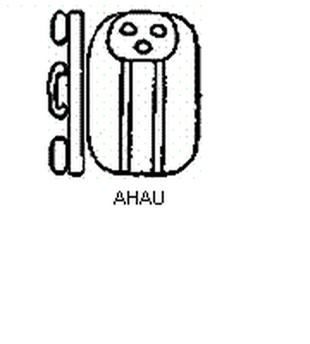 | “AHAU”  Maize stage: Seven plus the maize/Ajaw sign: the young ear, with the Jaguar Sun of the underworld beginning the hidden passage.  Distance: 8.6 light years — Earth to Sirius, the yardstick.  Time: 5,125 years (13 × baktun), in seven parts of 732 years.

What lies at this scale. Sirius, the Sun, and the elusive ninth planet, which at this time scale behaves as a sun (a ~7,400-year orbit).
The fourth glyph is the AHAU. Here the Sun and Sirius are neighbours, and a ninth planet, if it exists, would take about 7,400 years to orbit — a period of the same order as this 5,125-year scale, so at this time scale it behaves as a third sun.

The seven divisions
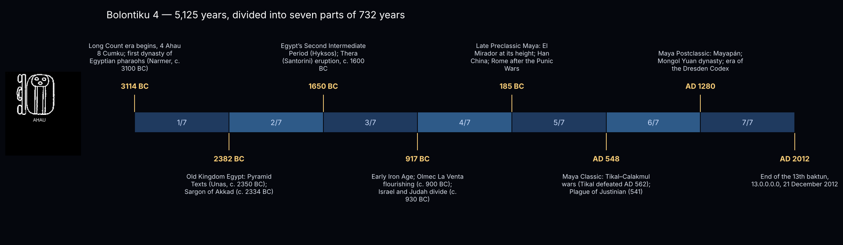
Figure 3. The fourth scale in seven equal parts.
Mark | Date | At or near this time
Start | 3114 BC | Long Count era begins, 4 Ahau 8 Cumku; first dynasty of Egyptian pharaohs (Narmer, c. 3100 BC)
1/7 | 2382 BC | Old Kingdom Egypt: Pyramid Texts (Unas, c. 2350 BC); Sargon of Akkad (c. 2334 BC)
2/7 | 1650 BC | Egypt’s Second Intermediate Period (Hyksos); Thera (Santorini) eruption, c. 1600 BC
3/7 | 917 BC | Early Iron Age; Olmec La Venta flourishing (c. 900 BC); Israel and Judah divide (c. 930 BC)
4/7 | 185 BC | Late Preclassic Maya: El Mirador at its height; Han China; Rome after the Punic Wars
5/7 | AD 548 | Maya Classic: Tikal–Calakmul wars (Tikal defeated AD 562); Plague of Justinian (541)
6/7 | AD 1280 | Maya Postclassic: Mayapán; Mongol Yuan dynasty; era of the Dresden Codex
End | AD 2012 | End of the 13th baktun, 13.0.0.0.0, 21 December 2012

4. Fifth Bolontiku (u5): The Ursa Major stream
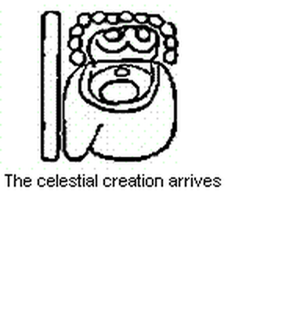 | “The celestial creation arrives”  Maize stage: Five plus the “arrival / grasping / creation” of divine matter (tzuk), still in the hidden phase.  Distance: 172 light years — The Ursa Major stream.  Time: 102,507 years (13 × piktun), in seven parts of 14,644 years.

What lies at this scale. The Big Dipper nucleus at about 80 ly and its stream members out to about 250 ly.
The Ursa Major moving group has its Big Dipper nucleus at about 80 light years and stream members out to about 250 light years; the yardstick of 172 light years lies inside that range.

The seven divisions
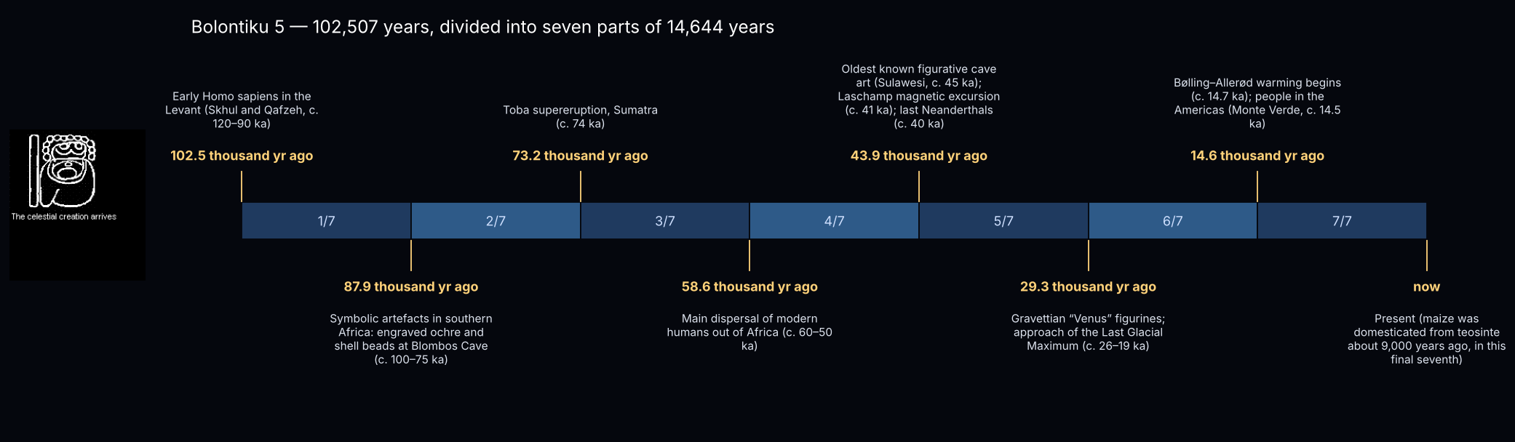
Figure 4. The fifth scale in seven equal parts.
Mark | Date | At or near this time
Start | 102.5 thousand yr ago | Early Homo sapiens in the Levant (Skhul and Qafzeh, c. 120–90 ka)
1/7 | 87.9 thousand yr ago | Symbolic artefacts in southern Africa: engraved ochre and shell beads at Blombos Cave (c. 100–75 ka)
2/7 | 73.2 thousand yr ago | Toba supereruption, Sumatra (c. 74 ka)
3/7 | 58.6 thousand yr ago | Main dispersal of modern humans out of Africa (c. 60–50 ka)
4/7 | 43.9 thousand yr ago | Oldest known figurative cave art (Sulawesi, c. 45 ka); Laschamp magnetic excursion (c. 41 ka); last Neanderthals (c. 40 ka)
5/7 | 29.3 thousand yr ago | Gravettian “Venus” figurines; approach of the Last Glacial Maximum (c. 26–19 ka)
6/7 | 14.6 thousand yr ago | Bølling–Allerød warming begins (c. 14.7 ka); people in the Americas (Monte Verde, c. 14.5 ka)
End | now | Present (maize was domesticated from teosinte about 9,000 years ago, in this final seventh)

5. Sixth Bolontiku (u6): The Orion Arm (about 3,500 ly wide)
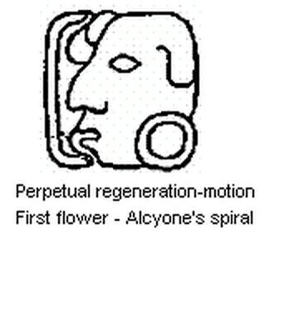 | “Perpetual regeneration-motion — First flower: Alcyone’s spiral”  Maize stage: Nine plus an undeciphered sign: the acceptance of the new state of the maize as a ripe plant.  Distance: 3,440 light years — The Orion Arm (about 3,500 ly wide).  Time: 2.05 million years (13 × kalabtun), in seven parts of 292,878 years.

What lies at this scale. The Orion Arm with the Pleiades (Alcyone), Orion and the Sun’s neighbourhood, carried round in perpetual motion.
The sixth and seventh scales share a perpetual motion: the Orion Arm is a density wave that stars pass through as they circle the Galaxy, renewing itself while its members change. The 3,440-light-year yardstick matches the arm’s width of about 3,500 light years.

The seven divisions
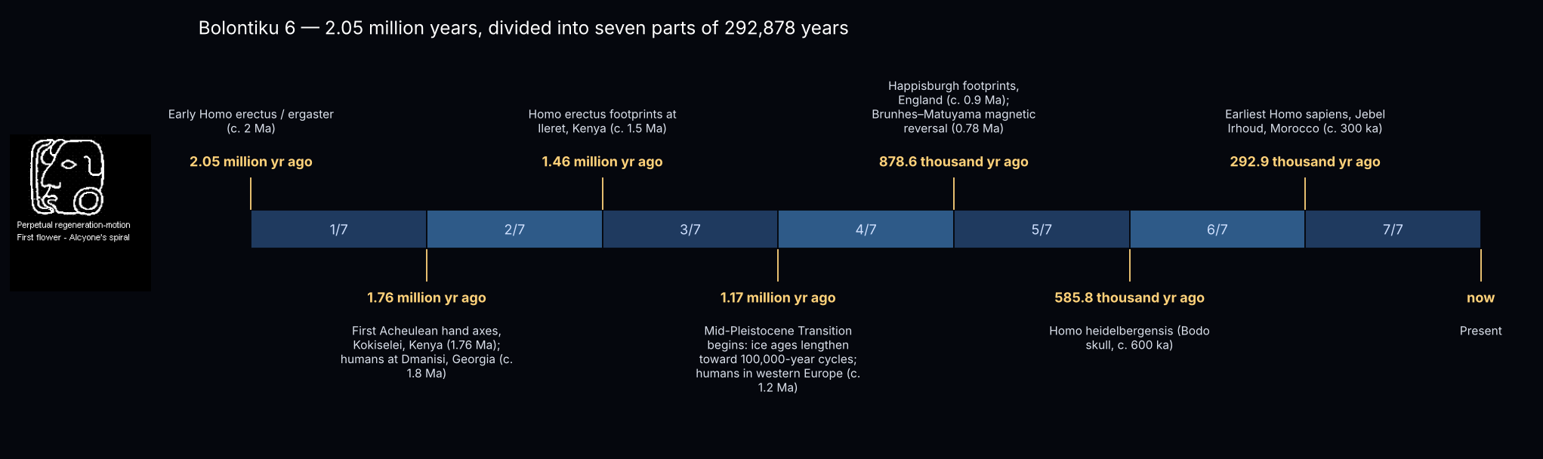
Figure 5. The sixth scale in seven equal parts.
Mark | Date | At or near this time
Start | 2.05 million yr ago | Early Homo erectus / ergaster (c. 2 Ma)
1/7 | 1.76 million yr ago | First Acheulean hand axes, Kokiselei, Kenya (1.76 Ma); humans at Dmanisi, Georgia (c. 1.8 Ma)
2/7 | 1.46 million yr ago | Homo erectus footprints at Ileret, Kenya (c. 1.5 Ma)
3/7 | 1.17 million yr ago | Mid-Pleistocene Transition begins: ice ages lengthen toward 100,000-year cycles; humans in western Europe (c. 1.2 Ma)
4/7 | 878.6 thousand yr ago | Happisburgh footprints, England (c. 0.9 Ma); Brunhes–Matuyama magnetic reversal (0.78 Ma)
5/7 | 585.8 thousand yr ago | Homo heidelbergensis (Bodo skull, c. 600 ka)
6/7 | 292.9 thousand yr ago | Earliest Homo sapiens, Jebel Irhoud, Morocco (c. 300 ka)
End | now | Present

6. Seventh Bolontiku (u7): The Galaxy (Milky Way)
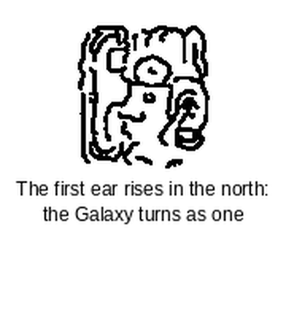 | “The first ear rises in the north: the Galaxy turns as one (proposed)”  Maize stage: na-(OCH)-NAL, “the first (entering of the) maize ear” — the first fully formed ear after the hidden phase; the same spelling as the word for north.  Distance: 68,800 light years — The Galaxy (Milky Way).  Time: 41.00 million years (13 × k’inchiltun), in seven parts of 5.86 million years.

What lies at this scale. The whole Milky Way, seen best from its north pole, turning as one body that carries the Orion Arm.
The meaning of the seventh glyph is proposed here from Gronemeyer’s reading “the first maize ear”, which is spelled like the word for north. The Galaxy is the first complete ear: one body that carries the Orion Arm round, best seen whole from its north pole. The yardstick of 68,800 light years is close to the distance across the disc along our line of sight, about 76,000 light years.

The seven divisions
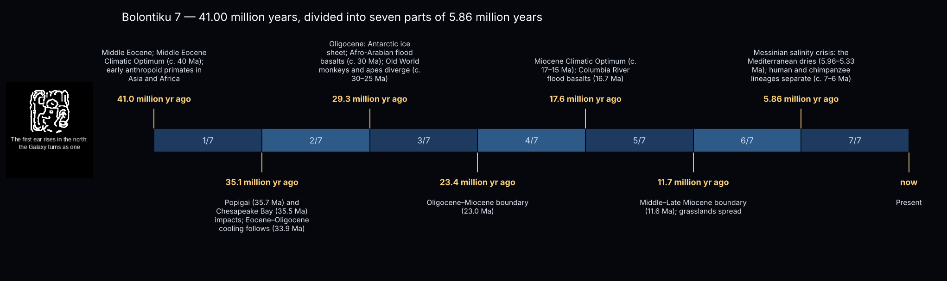
Figure 6. The seventh scale in seven equal parts.
Mark | Date | At or near this time
Start | 41.0 million yr ago | Middle Eocene; Middle Eocene Climatic Optimum (c. 40 Ma); early anthropoid primates in Asia and Africa
1/7 | 35.1 million yr ago | Popigai (35.7 Ma) and Chesapeake Bay (35.5 Ma) impacts; Eocene–Oligocene cooling follows (33.9 Ma)
2/7 | 29.3 million yr ago | Oligocene: Antarctic ice sheet; Afro-Arabian flood basalts (c. 30 Ma); Old World monkeys and apes diverge (c. 30–25 Ma)
3/7 | 23.4 million yr ago | Oligocene–Miocene boundary (23.0 Ma)
4/7 | 17.6 million yr ago | Miocene Climatic Optimum (c. 17–15 Ma); Columbia River flood basalts (16.7 Ma)
5/7 | 11.7 million yr ago | Middle–Late Miocene boundary (11.6 Ma); grasslands spread
6/7 | 5.86 million yr ago | Messinian salinity crisis: the Mediterranean dries (5.96–5.33 Ma); human and chimpanzee lineages separate (c. 7–6 Ma)
End | now | Present

7. Eighth Bolontiku (u8): Toward Andromeda (the Local Group’s balance point)
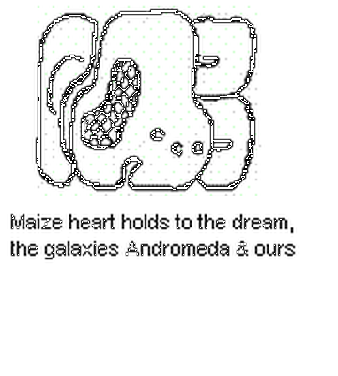 | “Maize heart holds to the dream, the galaxies Andromeda & ours”  Maize stage: OL, “heart”: the ripe ear kept as seed for the next sowing.  Distance: 1.38 million light years — Toward Andromeda (the Local Group’s balance point).  Time: 820.06 million years (13 × alawtun), in seven parts of 117.15 million years.

What lies at this scale. Andromeda and the Milky Way; the yardstick falls near the Local Group’s centre of mass (about 1.4 Mly from us).
The yardstick of 1.38 million light years is about half the distance to Andromeda (2.5 million light years). It falls near the Local Group’s centre of mass, about 1.4 million light years from us, between the two great galaxies the glyph names.

The seven divisions
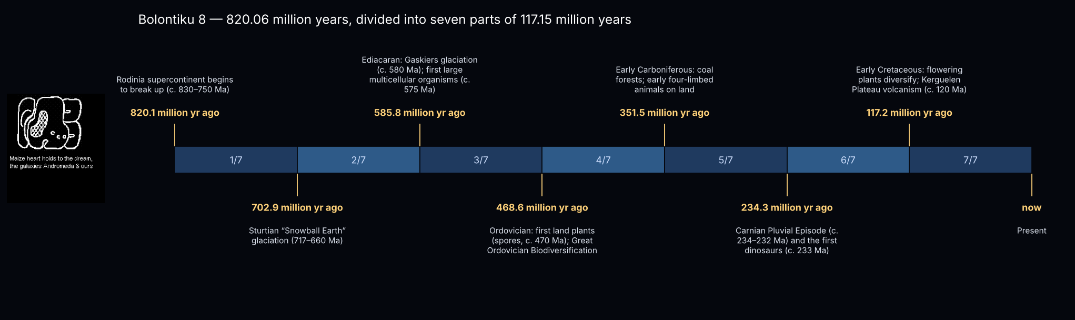
Figure 7. The eighth scale in seven equal parts.
Mark | Date | At or near this time
Start | 820.1 million yr ago | Rodinia supercontinent begins to break up (c. 830–750 Ma)
1/7 | 702.9 million yr ago | Sturtian “Snowball Earth” glaciation (717–660 Ma)
2/7 | 585.8 million yr ago | Ediacaran: Gaskiers glaciation (c. 580 Ma); first large multicellular organisms (c. 575 Ma)
3/7 | 468.6 million yr ago | Ordovician: first land plants (spores, c. 470 Ma); Great Ordovician Biodiversification
4/7 | 351.5 million yr ago | Early Carboniferous: coal forests; early four-limbed animals on land
5/7 | 234.3 million yr ago | Carnian Pluvial Episode (c. 234–232 Ma) and the first dinosaurs (c. 233 Ma)
6/7 | 117.2 million yr ago | Early Cretaceous: flowering plants diversify; Kerguelen Plateau volcanism (c. 120 Ma)
End | now | Present

8. Ninth Bolontiku (u9): The Local Group and the Local Volume around it
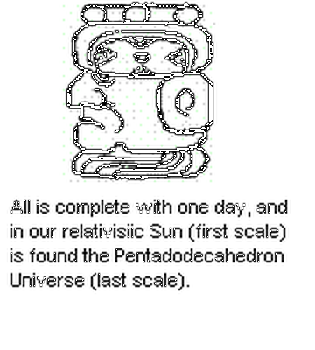 | “All is complete with one day, and in our relativistic Sun (first scale) is found the Pentadodecahedron Universe (last scale)”  Maize stage: K’IN, the (aged) Sun: completion of the cycle; every period ending falls on G9.  Distance: 27.52 million light years — The Local Group and the Local Volume around it.  Time: 16.4 billion years (13 × hablatun), in seven parts of 2.34 billion years.

What lies at this scale. The Local Group (about 10 Mly across) inside the ~30-Mly Local Volume, with the M81 and Sculptor groups.
The ninth glyph resembles the kin (Sun) glyph: the cycle closes where it began. Its 27.5 million light years reach beyond the Local Group (about 10 million light years across) to the Local Volume around it, and its 16.4 billion years reach beyond the measured age of the universe, 13.8 billion years.

The seven divisions
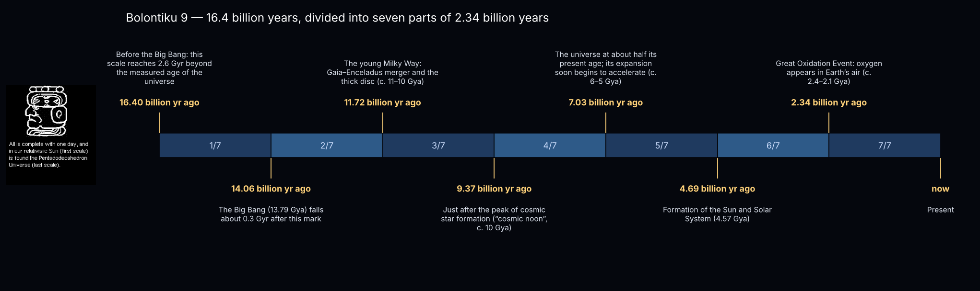
Figure 8. The ninth scale in seven equal parts.
Mark | Date | At or near this time
Start | 16.40 billion yr ago | Before the Big Bang: this scale reaches 2.6 Gyr beyond the measured age of the universe
1/7 | 14.06 billion yr ago | The Big Bang (13.79 Gya) falls about 0.3 Gyr after this mark
2/7 | 11.72 billion yr ago | The young Milky Way: Gaia–Enceladus merger and the thick disc (c. 11–10 Gya)
3/7 | 9.37 billion yr ago | Just after the peak of cosmic star formation (“cosmic noon”, c. 10 Gya)
4/7 | 7.03 billion yr ago | The universe at about half its present age; its expansion soon begins to accelerate (c. 6–5 Gya)
5/7 | 4.69 billion yr ago | Formation of the Sun and Solar System (4.57 Gya)
6/7 | 2.34 billion yr ago | Great Oxidation Event: oxygen appears in Earth’s air (c. 2.4–2.1 Gya)
End | now | Present

9. Notes
- Established: the nine G-glyphs and their nine-day cycle; G9 on every period ending; the Long Count units and the 13.0.0.0.0 date; the astronomical distances and the dated events, which are standard values given approximately (“c.”).
- Interpretation: the use of the nine glyphs as nested scales of space and time, the Earth–Sirius yardstick, the captions and the matching of scales to structures are our own, worked out together for this catalogue. Gronemeyer’s maize reading is itself a proposal, though widely discussed.
- Glyph order: in the row drawing used here (Bolontiku1.gif) the glyph labelled sixth looks more like Gronemeyer’s G7 examples, and his G6 is “nine” with an undeciphered sign. The order is worth checking against the original inscriptions.
- Glyph u7: cut from the same row drawing, then cleaned and smoothed, so its finer details are limited by the small original.
- Glyph drawings: the ancient inscriptions themselves are in the public domain, but a modern line drawing of a glyph can be the copyright of the person who drew it. Until the sources of the u1 to u9 drawings are confirmed, they are used here for study; redrawing them from photographs of the monuments would make them entirely our own.

10. Sources
- The London Chronicle, or Universal Evening Post, vol. 1 (January–June 1757); Library of Congress sn85054065.
- Gronemeyer, S. (2006). Glyphs G and F: Identified as Aspects of the Maize God. Wayeb Notes 22.
- Thompson, J. E. S. (1950). Maya Hieroglyphic Writing: An Introduction. Carnegie Institution.
- van Leeuwen, F. (2007). Hipparcos, the New Reduction of the Raw Data (Sirius: parallax 379.21 mas).
- King, J. R. et al. (2003), Astronomical Journal 125, 1980: the Ursa Major moving group.
- Karachentsev, I. D., Makarov, D. I. & Kaisina, E. I. (2013), Astronomical Journal 145, 101: the Local Volume galaxies.
- Brown, M. E. & Batygin, K. (2021), Astronomical Journal 162, 219: Planet Nine.
- Event dates: International Commission on Stratigraphy timescale; standard archaeological and astronomical chronologies.

